1. Difference between frontend, backend, and full-stack development
- Frontend Development
  - Works on the client side.
  - Deals with the visual appearance and user experience.
  - Ensures the website is responsive and interactive.
  - Example - The dining area, menu, and waiter that customers interact with in restaurant.
- Backend Development
  - Works on the server side.
  - Handles business logic, authentication, databases, and APIs.
  - Ensures data is stored securely and processed correctly.
  - The kitchen where chefs prepare food and manage orders.
- Full-Stack Development
  - Works on both client and server sides.
  - Can develop complete web applications independently.
  - Requires knowledge of both frontend and backend technologies.
  - A person who can both serve customers and cook the food, handling the entire restaurant process.
2. The client-server model
The client (web browser) sends a request to the server for a webpage. The server processes the request and sends the webpage back to the client, where it is displayed to the user.
3. Describe how a browser requests and displays a web page from a web server.
When a user enters a website URL, the browser sends an HTTP/HTTPS request to the web server after finding its IP address through DNS. The server returns the required files (HTML, CSS, JavaScript, and images), and the browser processes them to display the web page on the screen.
4. Identify and list the tools required to set up a web development environment. Explain the purpose of each.

Tools Required to Set Up a Web Development Environment
- Code Editor (VS Code): Used to write and edit website code such as HTML, CSS, and JavaScript.
- Web Browser (Chrome/Firefox): Used to view, test, and debug web pages.
- Git: Helps track changes in the code and manage different versions of a project.
- Node.js & npm: Used to run JavaScript outside the browser and install required packages.
- Local Server (Live Server/XAMPP): Allows developers to run and test websites on their local computer before deployment.

- Explain what a web server is and give examples of commonly used servers.

A web server is software or hardware that stores website files and delivers them to users' browsers when they request a web page using HTTP or HTTPS. It processes requests and sends the required content, such as HTML, CSS, JavaScript, and images.
Examples of commonly used web servers: Apache HTTP Server, Nginx, Microsoft IIS (Internet Information Services) and Caddy.
- Define the roles of a frontend developer, backend developer, and database administrator

- Frontend Developer: Designs and develops the user interface of a website or application using HTML, CSS, and JavaScript, ensuring a good user experience.
- Backend Developer: Builds the server-side logic, handles business processes, and manages communication between the frontend and the database.
- Database Administrator (DBA): Manages and maintains databases, ensuring data is stored securely, organized efficiently, and available when needed.
- Install VS Code and configure it for HTML, CSS, and JavaScript development.

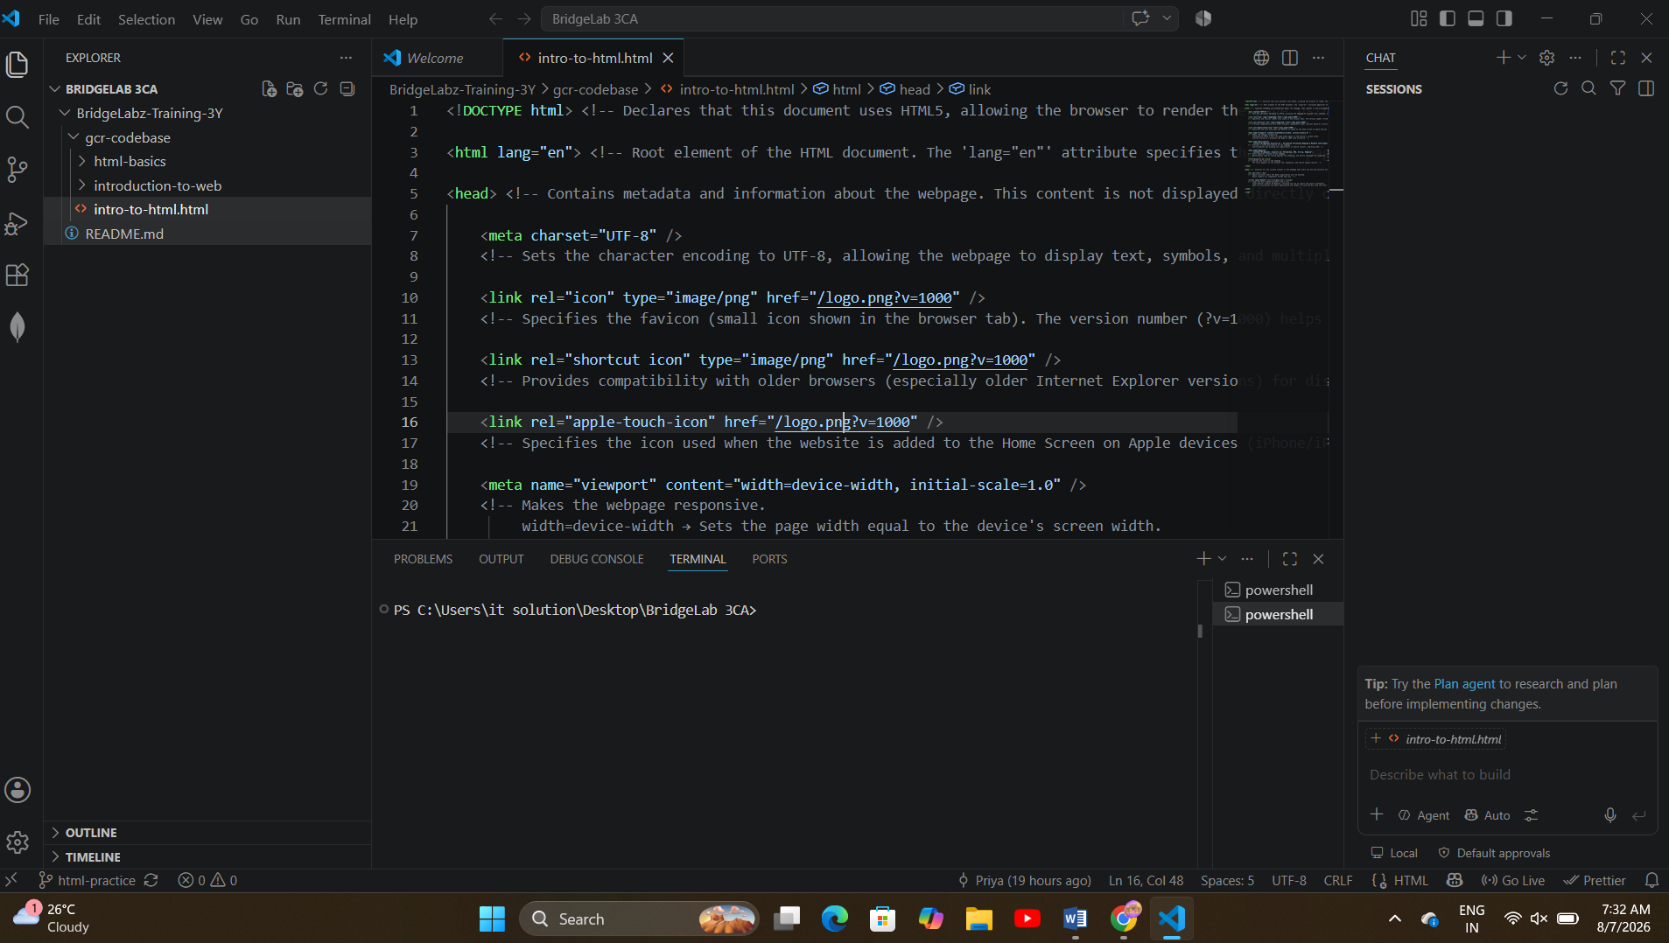

8. Explain the difference between static and dynamic websites. Provide an example of each.
A static website displays the same content to every user and is built using HTML, CSS, and JavaScript. Example: A personal portfolio or company brochure website.
A dynamic website generates content based on user interactions or data from a database. Example: Facebook, Amazon, or an online banking website.
9.Research and list five web browsers. Explain how rendering engines differ between them.

Five Web Browsers and Their Rendering Engines
- Google Chrome – Uses the Blink rendering engine.
- Mozilla Firefox – Uses the Gecko rendering engine.
- Microsoft Edge – Uses the Blink rendering engine.
- Apple Safari – Uses the WebKit rendering engine.
- Opera – Uses the Blink rendering engine.
Difference:
Rendering engines are responsible for displaying web pages. Blink, Gecko, and WebKit process HTML, CSS, and JavaScript differently, which can cause slight differences in the appearance and performance of websites across browsers.
10. Draw a labeled diagram showing the basic web architecture flow — client, server, database, and APIs.
Client (Browser) → Web Server → APIs/Database → Web Server → Client (Browser) → Web Page Displayed

